Magnetostrictive Transducer
Magnetostriction
Magnetostriction can be explained as the corresponding change in length per unit length produced as a result of magnetization. The material should be magnetostrictive in nature. This phenomenon is known as Magnetostrictive Effect. The same effect can be reversed in the sense that, if an external force is applied on a magnetostrictive material, there will be a proportional change in the magnetic state of the material. This property was first discovered by James Prescott Joule by noticing the change in length of the material according to the change in magnetization. He called the phenomenon as Joule effect. The reverse process is called Villari Effect or Magnetostrictive effect. This effect explains the change in magnetization of a material due to the force applied. Joule effect is commonly applied in magnetostrictive actuators and Villari effect is applied in magnetostrictive sensors.
This process is highly applicable as a transducer as the magnetostriction property of a material does not degrade with time.
Magnetostriction Transducers
A magnetostriction transducer is a device that is used to convert mechanical energy into magnetic energy and vice versa. Such a device can be used as a sensor and also for actuation as the transducer characteristics is very high due to the bi-directional coupling between mechanical and magnetic states of the material.
This device can also be called as an electro-magneto mechanical device as the electrical conversion to its appropriate mechanical energy is done by the device itself. In other devices, this operation is carried out by passing a current into a wire conductor so as to produce a magnetic field or measuring current induced by a magnetic field to sense the magnetic field strength.
Working
The figure below describes the exact working of a magnetostrictive transducer. The different figures explain the amount of strain produced from null magnetization to full magnetization. The device is divided into discrete mechanical and magnetic attributes that are coupled in their effect on the magnetostrictive core strain and magnetic induction.
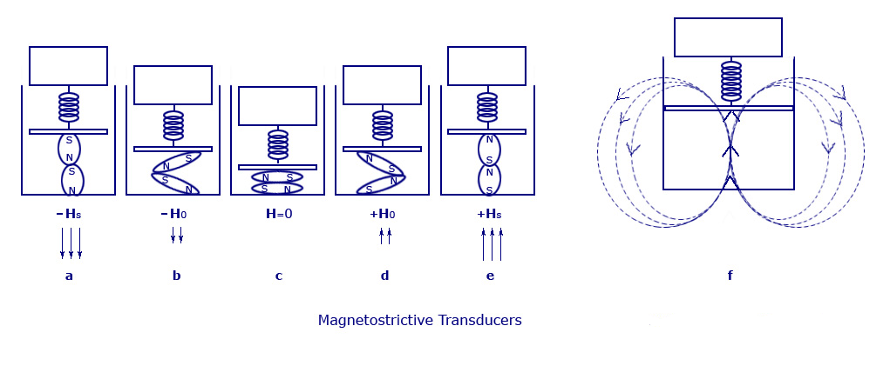
Magnetostrictive Transducers
First, considering the case where no magnetic field is applied to the material. This is shown in fig.c. Thus, the change in length will also be null along with the magnetic induction produced. The amount of the magnetic field (H) is increased to its saturation limits (±Hsat). This causes an increase in the axial strain to “esat”. Also, there will be an increase in the value of the magnetization to the value +Bsat (fig.e) or decreases to –Bsat (fig.a). The maximum strain saturation and magnetic induction is obtained at the point when the value of Hs is at its maximum. At this point, even if we try to increase the value of field, it will not bring any change in the value of magnetization or field to the device. Thus, when the field value hits saturation, the values of strain and magnetic induction will increase moving from the center figure outward.
Let us consider another instance, where the value of Hs is kept fixed. At the same time, if we increase the amount of force on the magnetostrictive material, the compressive stress in the material will increase on to the opposite side along with a reduction in the values of axial strain and axial magnetization.
In fig.c, there are no flux lines present due to null magnetization. Fig.b and fig.d has magnetic flux lines in a much lesser magnitude, but according to the alignment of the magnetic domains in the magnetostrictive driver. Fig.a also has flux lines in the same design, but its flow will be in the opposite direction. Fig.f shows the flux lines according to the applied field Hs and the placing of the magnetic domains. These flux fields produced are measured using the principle of Hall Effect or by calculating the voltage produced in a conductor kept in right angle to the flux produced. This value will be proportional to the input strain or force.
Applications
The applications of this device can be divided into two modes. That is, one implying Joule Effect and the other are Villari Effect.
- In the case where magnetic energy is converted to mechanical energy it can be used for producing force in the case of actuators and can be used for detecting magnetic field in the case of sensors.
- If mechanical energy is converted to magnetic energy it can be used for detecting force or motion.
- In early days, this device was used in applications like torque meters, sonar scanning devices, hydrophones, telephone receivers, and so on. Nowadays, with the invent of “giant” magnetostrictive alloys, it is being used in making devices like high force linear motors, petitioners for adaptive optics, active vibration or noise control systems, medical and industrial ultrasonic, pumps, and so on. Ultrasonic magnetostrictive transducers have also been developed for making surgical tools, underwater sonar, and chemical and material processing.

